October 2020

Halloween

enviromental awareness campaign

background
Candy & Snack wrappers are made of several layers of different materials, called multilayer packaging. The layers are great to keep the food fresh and prevent spoiling. However, it makes very hard to recycle them, as it would involve layer separation before recycling.
Those wrappers are not a recyclable material in the curbside recycling or at a county drop-off location. It goes in the garbage (green) bin, ending in the landfill and often being blown away to streets, forests and rivers, taking over 20 years to decompose.
A recent report from Ocean Conservancy found candy & snack wrappers as the top litter in the ocean. The 2019 Global Beach Cleanup had 116 countries participating, covering 24,000 miles of coast and gathering 20.8 million tons of trash. Cigarette butts, 34 years top litter, were dethroned by candy & snack wrappers, with 4.7 million individual wrappers gathered.
TerraCycle is the only company that recycles candy & snack wrappers, making sure they do not end up in the landfill. All we need to do is to collect the wrappers in a box and send to them.
Next time you reach for that sweet treat, think of the life cycle of that piece of candy. You don’t need to hold back — just plan to upcycle or recycle your wrappers.

Listed below are some examples of initiatives on how schools can get involved and help solve this problem, while educating the kids about the environment and, also, science! We will be helping to implement those initiatives and act as facilitators.

candy wrappers collection
TerraCycle collection boxes can be bought by the school, parents or anyone wishing to help. Chocolate, cereal bar, potato ships and goldfish are examples of wrappers that can be collected in a snack and candy wrappers box. Shipping label is included with the box.

Collection points

School drop-off: collection boxes outside of the school for easy drop-off.

Parent’s houses: we have already identified a few families in North Buckhead willing to have the collection box in their front porches.

Period

To the discretion of the school. We suggest from the week before Halloween (10/26/2020) to National Recycling Day on Nov 15th.

Poster (What You Can Recycle)

We will provide an “Accepted Waste Poster” with description and pictures of materials accepted in the box.

End of collection:

Once collection period is over, we will take care of the box and send it back to TerraCycle for recycling.

Art projectS
Upcycle those wrappers with a beautiful artwork that could be done at home during virtual learning or in-person. A box can be decorated with wrappers to collect wrappers at the classroom or at home. A artwork could be small as a wallet or big as a mural. A few examples below:
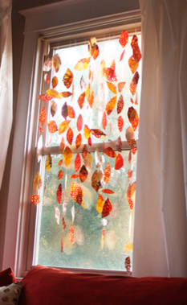 | 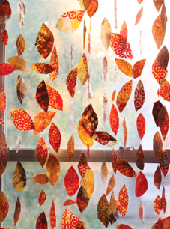 | 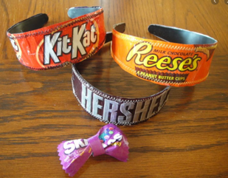
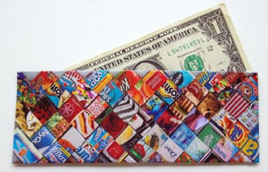 | 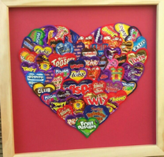 | 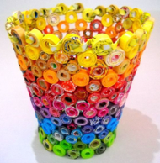
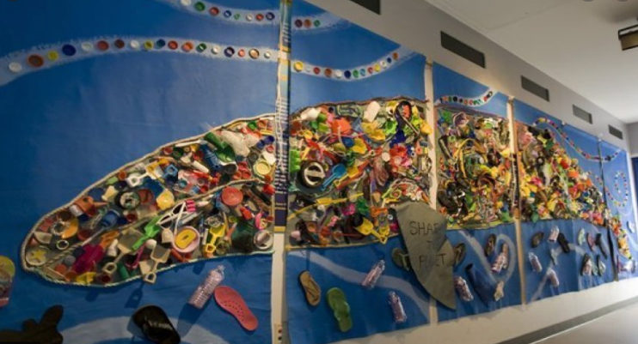 |  | 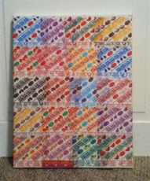  Collection box decorated with wrappers

classroom education

Worksheets: we can provide worksheets about plastic recycling for the teachers to work in class. Material science content can be covered upon the grade level.

Mystery Reader: we or one of the students will read a book about environmental education for the class.

Little Green Ambassadors: We will ask for “Green Ambassador” volunteers. Those would be the green champions by grade level and will record a video or make a presentation about wrapper’s recycling to the class.

We can have videos recorded in different languages, given the international nature of some schools. We will help with content and video recording/editing.

litter picking challenge

There is an app called Litterati that helps to organize litter picking challenges in the community. The app tracks the type of litter and the location, adding to a big database that is helping companies to shift their products or the way they sell. This could be a fun outdoor activity in a park or any area close to the school.

Contact:

Leticia Socal

leticiasocal@hotmail.com

215-407-1060

